 HOW TO USE LIBRARIKA
https://uucr.librarika.com/

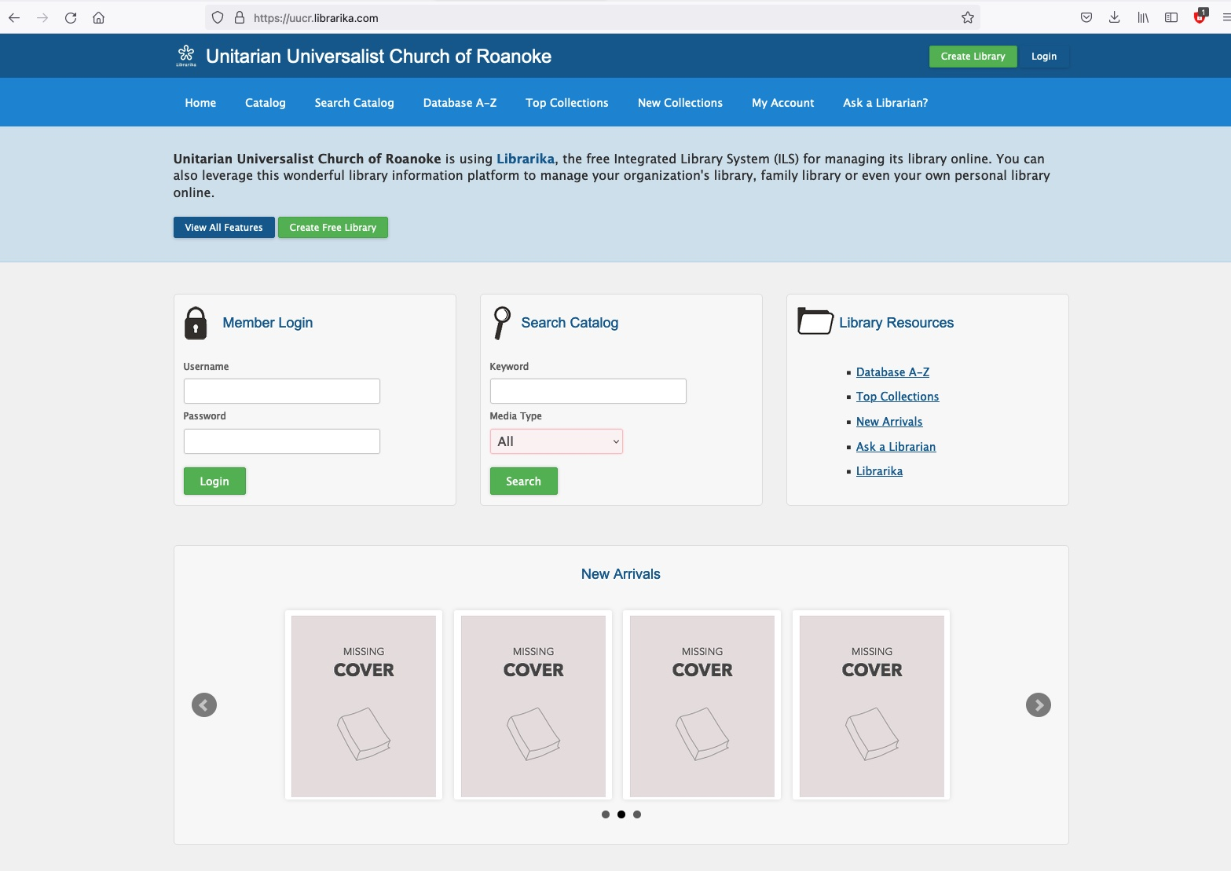

You can now search the UUCR Library collection from your own computer! Below are some basic tips.

- Ignore the member login. We are not set up at this time for online check out/returns, which would require member logins. You must check out books the old-fashioned way – see instructions in the Olin Room.
- Search the collection. There are two ways:
  - From the home page, simply type in key words in the “Search Catalog” field provided. (Ignore “Media Type” – all we have are books.)
  - For more advanced searching, click on “Search Catalog” in the upper navigation menu (or go here: https://uucr.librarika.com/search). From the “Default” drop down menu, you can select specific elements of the book’s identity, such as Title or Author, to search by. Or you can simply drop in keywords, also known as “tags.”
  - NOTE: When you search (versus browse), the system generates a unique “search results” page for you based on the keywords you searched with. To return to the full results page after clicking on any given title in the results:
    - Hit the “back” arrow in your web browser.
    - You’ll see a page that says, “Document Expired” – simply hit “Try Again” or refresh the page, then…
    - Hit the blue button, “Resend”.
    - You should be returned to your search results page.
    - Yes, it’s annoying! Browse works differently because those lists are not uniquely generated. You can navigate from a Browse list to a book on that list and back to the Browse list simply with the back button.
- Browse the collection. There are multiple ways:
  - On the home page, see your choices under “Library Resources.”
  - On any page within the website, you can see these same links along the top navigation menu.
  - From the advanced search page (https://uucr.librarika.com/search), you can also browse the collection by clicking on Categories or Authors or Publishers or Tags (keywords) or Series (though not much is in a series).
  - NOTE:
    - “Catalog” = all books in the collection, alphabetical by title.
    - “Database A-Z” = groups titles by first letter.
    - “Top Collections” and “New Collections” and “New Arrivals” = not really sure yet how these designations are assigned by the system. Still learning the platform!

